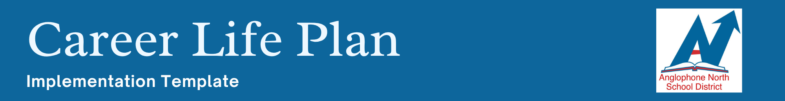

School: | Date:

Refer to the Career Life Plan Companion Document for support in completing this implementation plan.

Minimum Requirements for the Career Life Plan

EXPLORING EVIDENCE OR ARTIFACT:
☐ Complete the five assessments in myBlueprint (Learning Styles, Personality, Interest Survey, Knowledge, and Motivation)
☐ Identify two or more career-life pathways of interest
☐ Identify post-secondary pathways connected to a Career Life Plan

EXPERIENCING EVIDENCE OR ARTIFACT:
☐ Develop resume writing skills
☐ Develop cover letter writing skills
☐ Engage in an interview opportunity
☐ Participate in an authentic Career-Connected Experiential Learning opportunity
☐ Engage in a student-led conference of the completed Career Life Plan

THINKING EVIDENCE OR ARTIFACT:
☐ Create a goal to show preparation for life beyond high school
☐ Develop an action plan to work toward a career pathway
☐ Develop a financial plan that considers life beyond high school

School Plan for Meeting the Minimum Requirements:
Utilize the information on pages 9-12 to select the structures you will leverage to implement the Career Life Plan in your school. Remember to consider Alt Sites (APL) in your plan. List the structures below:

Structure: | How it will be leveraged:
Ex: Grade 12 Interview with school counsellor or advisor | Engage in a student-led conference of the completed Career Life Plan
Ex: AARAO | Participate in an authentic Career-Connected Experiential Learning opportunity
Ex: Personal Wellness 9 | In this class, all students will complete the following CLP requirements:  - five assessments in myBluePrint  - identify two or more career life pathways of interest  - identify post-secondary pathways connected to a Career Life Plan.  - create a goal to show preparation for life beyond high school
Ex: Career Life Plan Micro-Course | All APL students will complete the Online Career Life-Plan Micro-Course

What is your process for tracking student checklists?

Who will input the PowerSchool code when a student completes the Career Life Plan?

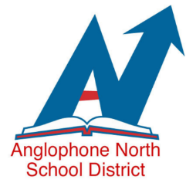
Career Life Plan
Recommended Pathway

Although the minimum requirements are what is required for the Career Life Plan graduation requirement, it is good practice for high school learners to continuously revisit their career life plans. This recommended pathway document can help you with your planning.

Grade | Requirements Focus
Grade 9 | Through Personal Wellness 9, all learners will use the myBluePrint platform. The following CLP requirements will be covered in this course:  - five assessments in myBluePrint  - identify two or more career life pathways of interest  - identify post-secondary pathways connected to a Career Life Plan  - create a goal to show preparation for life beyond high school
Grade 10 | Through ELA (or another agreed upon required class – i.e. Career Pathway Design), complete the following:  - Develop resume writing skills  - Develop cover letter writing skills  - Develop an action plan to work toward a career pathway  - Engage in an interview opportunity  Through GMF 10, cover the following CLP requirement:  - Develop a financial plan that considers life beyond high school
Grade 11 | Through ELA (or another agreed upon required class), all students will revisit these requirements at least once (plans may have changed since Grade 9):  - five assessments in myBluePrint  - identify two or more career life pathways of interest  - identify post-secondary pathways connected to a Career Life Plan  - create a goal to show preparation for life beyond high school
Grade 12 | - Participate in an authentic Career-Connected Experiential Learning opportunity (i.e. AARAO, Career Fair)  School Counsellor or other designated educator to complete the following:  - Engage in a student-led conference of the completed Career Life Plan

